**4. Relations**

**Relations** exists between objects of the same set or between objects of two or more sets.

A binary relation R from set x to y (written as xRy or R(x, y)) is a subset of the Cartesian product x X y.

Generally an n-ary relation R between sets A1, ... , and An is a subset of the n-ary product A1 × ... × An. The minimum cardinality of a relation R is Zero and maximum is n2 in this case.

A binary relation R on a single set A is a subset of A × A.

For two distinct sets, A and B, having cardinalities *m* and *n* respectively, the maximum cardinality of a relation R from A to B is *mn*.

### **Examples**

Let, A = {1, 2, 9} and B = {1, 3, 7}

* Case 1 − If relation R is ‘equal to’ then R = {(1, 1), (3, 3)}
* Case 2 − If relation R is ‘less than’ then R = {(1, 3), (1, 7), (2, 3), (2, 7)}
* Case 3 − If relation R is ‘greater than’ then R = {(2, 1), (9, 1), (9, 3), (9, 7)}

**Product of Sets/Cartesian product**

Consider two sets A and B where A = {1, 2}, B = {3, 4, 5}.

Set of all ordered pairs of elements of A and B is

{(1,3), (1,4), (1,5), (2,3), (2,4), (2,5)}

This set is denoted by A × B and is called the Cartesian product of sets A and B.

i.e. A×B = {(1, 3), (1, 4), (1, 5), (2, 3), (2, 4), (2, 5)}

Cartesian product of B sets and A is denoted by B×A. In the present example, it is given by

B×A = {(3, 1), (3, 2), (4, 1), (4, 2), (5, 1),(5, 2)}

## **Domain and Range**

If there are two sets A and B, and relation R have order pair (x, y), then −

* The **domain** of R is the set { x | (x, y) ∈ R for some y in B }
* The **range** of R is the set { y | (x, y) ∈ R for some x in A }

**Example**

Given that A = {2, 4, 5, 6, 7}, B = {2, 3}. R is a relation from A to B defined by

Find

(i) R as a set of ordered pair

(ii) Domain of R

(iii) Range of R

(iv) Represent R diagrammatically.

Solution :

(i) R = {(2, 2), (4, 2), (6, 2), (6, 3)}

(ii) Domain of R = {2, 4, 6}

(iii) Range of R = {2, 3}

(iv)

|  |
| --- |
| **Domain Range** |

**Example:**

If R is a relation 'is greater than' from A to B, where A= {1, 2, 3, 4, 5} and B = {1, 2, 6}. Find

1. R as a set of ordered pair
2. Domain of R
3. Range of R.

Solution : (i) R = {(3, 1), (3, 2), (4, 1), (4, 2), (5, 1), (5, 2)}

(ii) Domain of R = {3, 4, 5}

(iii) Range of R = {1, 2}

**Inverse Relation**

The inverse of a relation is formed by interchanging the components of each of the ordered pairs in the given relation.

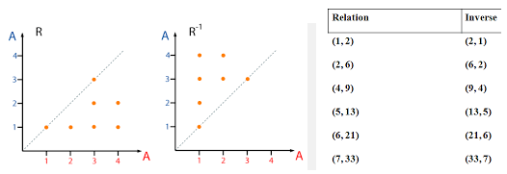

**Q. Graph the inverse of each relation**

**Ex-1**

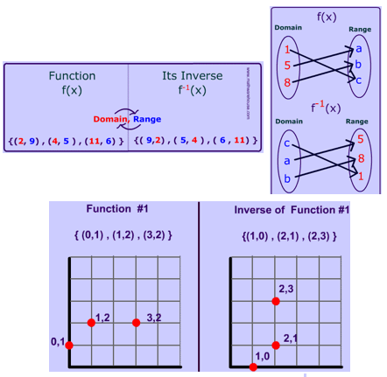

**Ex-2**

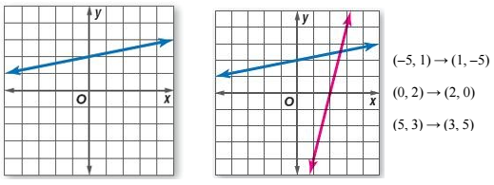

The graph of the relation passes through the points at (-5, 1), (0, 2), and (5, 3).

To find points through which the inverse passes, exchange the coordinates of the ordered pairs

**Rules of finding Inverse**

**Example-1**

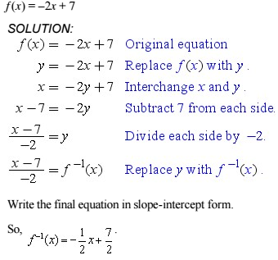

**Example-2**

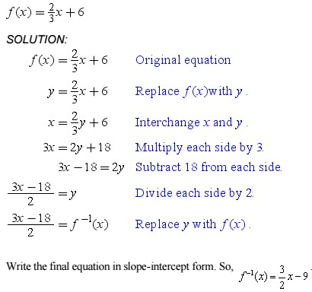

**D**[**irected graph representing the inverse relation**](http://math.stackexchange.com/questions/74515/directed-graph-representing-the-inverse-relation)

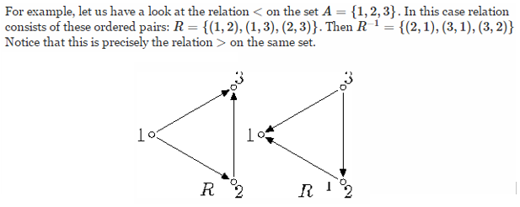

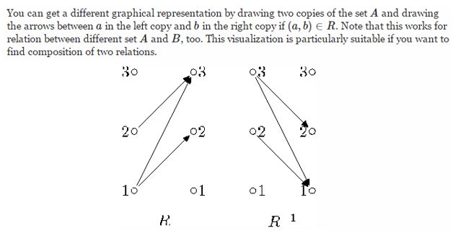

Representing Relations:

1. Graphical/Mapping Method
2. Table Method

Relations can be represented graphically, as shown below, using arrows to represent the ordered pairs. Another way is to use a table to represent relations.

Let *A* = {0, 1, 2} and *B* ={*a, b*}, then {(0, *a*), (0, *b*), (1, *a*), (2, *b*)} is a relation from *A* to *B*. That means 0 is related to *a*, but 1 is not related to *b*.

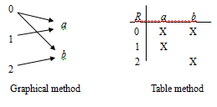

Example

Let *A* = {1, 2, 3, 4}. Which ordered pairs are in the relation *R* ={(*a, b*) : *a* divides *b* }? Represent the relation by graphical and table method.

Ans:

Since (*a, b*) is in *R* if and only if *a* and *b* are positive integers not exceeding 4 such that *a* divides *b*, we see that

*R* = {(1, 1), (1, 2), (1, 3), (1, 4), (2, 2), (2, 4), (3, 3), (4, 4)}

The pairs in this relation are displayed both in graphical/mapping and in tabular form below.

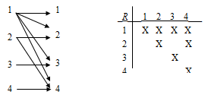

Example

Consider the following relations on the set of integers:

*R*1 = {(*a*, *b*) : *a* < *b* }

*R*2 = {(*a*, *b*) : *a* > *b* }

*R*3 = {(*a*, *b*) : *a* = *b* or *a* = –*b*}

*R*4 = {(*a*, *b*) : *a* = *b* }

*R*5 = {(*a*, *b*) : *a* = *b* + 1 }

*R*6 = {(*a*, *b*) : *a* + *b* < 3 }.

Which of these relations contain (1, 1), (1, 2), (2, 1), (1, –1) or (2, 2)?

*R*1 = {(1, 1), (1, 2), (2, 2)}

*R*2 = {(2, 1), (1, –1)}

*R*3 = {(1, 1), (1, –1), (2, 2)}

*R*4 = {(1, 1), (2, 2)}

*R*5 = {(2, 1)}

*R*6 = {(1, 1), (1, 2), (2, 1), (1, –1)}

The pair (1, 1) is in *R*1, *R*3, *R*4 and *R*6;

The pair (1, 2) is in *R*1 and *R*6;

The pair (2, 1) is in *R*2, *R*5, and *R*6;

The pair (1, –1) is in *R*2, *R*3, and *R*6; and finally,

The pair (2, 2) is in *R*1, *R*3and *R*4.

Also there are many ways to represent a relation between finite sets. One way is to list its ordered pairs which we have already seen, here we would introduce two alternative methods for representing relations:

(a) Representing relations using matrices

(b) Representing relations using directed graphs

**(a) Using Matrices**

A relation between finite sets can be represented using a zero-one matrix. Suppose that *R* is a relation from *A* = {*a*1, *a*2, ……*a*m} to *B* = {*b*1, *b*2, ……*b*n}. The relation *R* can be represented by the matrix  where



Example

Suppose that *A* = {1, 2, 3} and *B* ={1, 2}. Let *R* be the relation from *A* to *B* containing (*a*, *b*) if *a* ∈ *A*, *b* ∈ *B*, and *a* > *b*. What is the matrix representing *R* if *a*1 = 1, *a*2 = 2, *a*3 = 3, *b*1 = 1 and *b*2 = 2 ?

Since *R* = {(2, 1), (3, 1), (3, 2)}, the matrix for *R* is

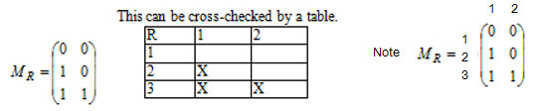

The 1’s in *MR* show that the pairs (2, 1), (3, 1) and (3, 2) belong to *R.* The 0’s show that no other pairs belong to *R*.

**Example**

Suppose that *A* = {*a*1, *a*2, *a*3} and *B* = {*b*1, *b*2, *b*3, *b*4, *b*5}.

Which ordered pairs are in the relation *R* represented by the matrix

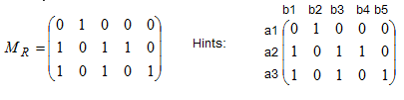

Ans: *R* = {(*a*1, *b*2), (*a*2, *b*1), (*a*2, *b*3), (*a*2, *b*4), (*a*3, *b*1), (*a*3, *b*3), (*a*3, *b*5)}.

**(b) Using directed graphs**

A relation can be represented using a directed graph.

The number of vertices in the graph is equal to the number of elements in the set from which the relation has been defined. For each ordered pair (x, y) in the relation R, there will be a directed edge from the vertex ‘x’ to vertex ‘y’. If there is an ordered pair (x, x), there will be self- loop on vertex ‘x’.

Suppose, there is a relation R = {(1, 1), (1, 2), (3, 2)} on set S = {1, 2, 3}, it can be represented by the following graph −

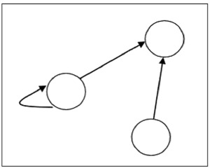

S = {1, 2, 3}

A directed graph consists of a set *V* of vertices (or nodes) together with a set *E* of ordered pairs of elements of *V* called edges (or arcs). The vertex *a* is called the initial vertex of the edge (*a, b*), and the vertex *b* is called the terminal vertex of this edge.

**Example**

1. The directed graph with vertices *a*, *b*, *c*, and *d*, and edges (*a*, *b*), (*a*, *d*), (*b*, *b*), (*b*, *d*), (*c*, *a*), (*c*, *b*) and (*d*, *b*) is drawn as the graph below.

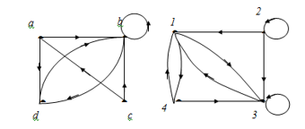

(i) (ii)

1. What are the ordered pairs in the relation *R* represented by the directed graph shown in graph below.

*R* = {(*1*, *3*), (*1*, *4*), (*2*, *1*), (*2*, *2*), (*2*, *3*), (*3*, *1*), (*3*, *3*), (*4*, *1*), (*4*, *3*)}.

Each of these pairs corresponds to an edge of the directed graph, with (2, 2) and (3, 3) corresponding to loops.

## **Types of Relations**

* The **Empty Relation** between sets X and Y, or on E, is the empty set ∅
* The **Full Relation** between sets X and Y is the set X × Y
* The **Identity Relation** on set X is the set {(x, x) | x ∈ X}
* The Inverse Relation R' of a relation R is defined as − R’ = {(b, a) | (a, b) ∈ R}

**Example** − If R = {(1, 2), (2, 3)} then R’ will be {(2, 1), (3, 2)}

**Other Relations**

1. **Reflexive/Reflexivity –** A relation R on a set A is reflexive if aRa for every a $∈$**A**, that is if (a, a) $∈$ R for every a $∈$**A.** Thus **R** is not reflexive if there exists an a $∈$ A such that (a, a) http://staff.scm.uws.edu.au/~zhuhan/dm_notes/tex/notin.gif **R**. Having at least a loop on each vertex.

* A relation R on set A is called **Reflexive** if ∀a∈A is related to a (aRa holds).
* The relation R = {(a, a), (b, b)} on set X = {a, b} is reflexive.

**Example**

Consider the following five relations on the set A = {1 ,2, 3, 4}.

$R_{1}$ ={ (1,1), (1,2), (2,3), (1,3), (4,4) }.

$R_{2}$ ={ (1,1), (1,2), (2,1), (2,2), (3, 3), (4,4) } .

$R_{3}$ ={(1,3), (2,1) } .

$R_{4}$ = $∅$, the empty relation.

$R_{5}$ = A x A, the universal relation.

Since A contain the four elements 1, 2, 3, and 4; a relation R on A is reflexive if it contains the four pairs (1,1), (2,2), (3,3), and (4,4).

Thus only $R_{2}$ and the universal relations $R_{5}$ = A x A are reflexive.

And a relation R on set A is called **Irreflexive** if no a ∈ A is related to a (aRa does not hold).

**Example** − The relation R = {(a, b), (b, a)} on set X = {a, b} is irreflexive.

1. **Symmetry**: A relation R on a set A is symmetric if whenever aRb then bRa, that is, if whenever (a, b) $∈$**R** then (b, a) $∈$**R.**  Thus R is not symmetric (Anti-Symmetric) if there exists such that (a, b) $∈$**R but** (b, a) $∈$/ **R** (means any arrow from one vertex to another will always be accompanied by another arrow in the opposite direction).

$R_{1}$ is not symmetric since (1,2) but (2,1) http://staff.scm.uws.edu.au/~zhuhan/dm_notes/tex/notin.gif

Similarly

$R_{3}$ is not symmetric since (1,3) $∈R_{3}$ but (3,1) $∈/R_{3}$

The other relations are symmetric.

So, A relation R on set A is called **Symmetric** if xRy implies yRx, ∀x∈A and ∀y∈A.

* **Ex** − The relation R = {(1, 2), (2, 1), (3, 2), (2, 3)} on set A = {1, 2, 3} is symmetric.

And a relation R on set A is called **Anti-Symmetric** if xRy and yRx implies x = y ∀x ∈ A and ∀y ∈ A.

* **Ex** − The relation R = {(1, 2), (3, 2)} on set A = {1, 2, 3} is antisymmetric.

1. **Transitivity**: A relation R on a set is transitive if whenever aRb and bRc then aRc, that is, if whenever (a,b), (b,c) $∈$ R then (a, c) $∈$ R. Thus R is not transitive if there exist a,b,c $∈$ A such that (a,b), (b,c) $∈$ R but (a, c) $∈/$ R.

* The relation $R_{3}$ is not transitive since (2,1), (1,3) but (2,3) http://staff.scm.uws.edu.au/~zhuhan/dm_notes/tex/notin.gif
* So A relation R on set A is called **Transitive** if xRy and yRz implies xRz, ∀x,y,z ∈ A.

**Example** − The relation R = {(1, 2), (2, 3), (1, 3)} on set A = {1, 2, 3} is transitive

1. **Equivalence Relation** if it is reflexive, symmetric, and transitive.

**Example** − The relation R = {(1, 1), (2, 2), (3, 3), (1, 2), (2,1), (2,3), (3,2), (1,3), (3,1)} on set A = {1, 2, 3} is an equivalence relation since it is reflexive, symmetric, and transitive.

**Examples**

Let *A={ 0,1,2,3}* and a relation *R* on *A* be given by

*R={ (0,0), (0,1), (0,3), (1,0), (1,1), (2,2), (3,0), (3,3) } .*

Is *R* reflexive? Symmetric? Transitive?

**Solution** 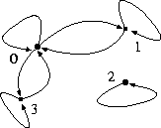

1. *R* is reflexive, i.e. there is a loop at each vertex.
2. *R* is symmetric, i.e. the arrows joining a pair of different vertices always appear in a pair with opposite arrow directions.
3. *R* is not transitive. This is because otherwise the arrow from 1 to 0 and arrow from 0 to 3 would imply the existence of an arrow from 1 to 3 (which doesn't exist). In other words  *(1,0) http://staff.scm.uws.edu.au/~zhuhan/dm_notes/tex/in.gif R*, *(0,3) http://staff.scm.uws.edu.au/~zhuhan/dm_notes/tex/in.gif R*  and *(1,3)*http://staff.scm.uws.edu.au/~zhuhan/dm_notes/tex/notin.gif*R* imply

*R* is not transitive.

**Note** It is equally easy to show these properties without resorting to the digraph.